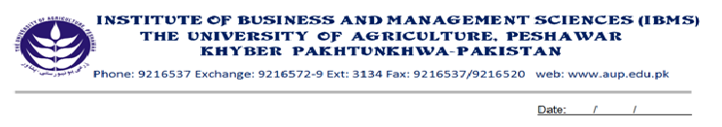
Program: BS (CS)-I
Course Name: Calculus & Analytical Geometry
Course Code: MT-301
Session: 2012-2015
Course Hours: 03
Total Weeks: 16
Total Hours: 48

Course Objectives
Calculus is a vast subject. It has many applications in Engineering Sciences as well as in computer Sciences. It enables the students to define slopes of curves, to calculate velocity and acceleration of moving bodies. That’s why, the above course is planned for BS(CS) students. The course contents are such that, after the completion of this course, students will be able to differentiate and integrate algebraic as well as trigonometric functions, at the end of the course student will be able to apply the concepts while solving problems of computers.

Week-1
-Complex Numbers

Week-2
-Complex Numbers in Polar Form
-De-Movire’s Theorem
-Applications of De-Moivre’s Theorem

Week-3
-Functions and Graphs

Week-4
-Limits of Different Functions,
-Left Hand Limits and Right Hand Limits

Week-5
-Continuity of Different Functions

Week-6
-Differentiation, Rules of Differentiation
-Derivatives of Algebraic Functions

Week-7
-Derivatives of Trigonometric and Inverse Trigonometric Functions

Week-8
-Chain Rule
-Applications of Chain Rule

Week-9
-Equation of Tangent
-Equation of Normal

Week-10
-Maxima, Minima and Point of Inflection

Week-11
-Taylor Series
-Maclaurin Series

Week-12
-Integration of Simple Functions
-Rules of Integrations

Week-13
-Integration by Substitution
- Integration by Parts

Week-14
-Integration by Partial Fractions

Week-15
-Definite Integrals
-Properties of Definite Integrals

Week-16
-Applications of Definite Integrals

Total Marks: 100

Recommended Book:
1. Calculus by Thomas/Finney 9th Edition
2. Advance Engineering Mathematics by Erwin Kreyszig 8th Edition
3. Calculus and Analytical Geometry by Dr. Zia ul Haq

